AFH Chapter 18 – Emergencies (Draft A v1)
EAA Power-loss on Takeoff Working Group Edits, February 2026
Edits in BOLD red font

Introduction
This chapter describes certain abnormal and emergency situations that may occur in flight. The key to successful management of an emergency situation, and/or preventing an abnormal situation from progressing into a true emergency, is a thorough familiarity with, and adherence to, the procedures developed by the airplane manufacturer. The following guidelines are generic and are not meant to
replace the airplane manufacturer’s recommended procedures contained in the Federal Aviation Administration (FAA) approved Airplane Flight Manual and/or Pilot’s Operating Handbook (AFM/POH). Rather, they are meant to enhance the pilot’s general knowledge in abnormal and emergency operations. If any of the guidance in this chapter conflicts in any way with the manufacturer’s recommended procedures for a particular make and model airplane, the manufacturer’s recommended procedures take precedence.

Emergency Landings
This section contains information on emergency landing techniques in small fixed-wing airplanes. The guidelines that are presented apply to the more adverse terrain conditions for which no practical training is possible. The objective is to instill in the pilot the knowledge that almost any terrain can be considered “suitable” for a survivable crash landing if the pilot knows how to use the airplane structure for self-protection and the protection of passengers.
Types of Emergency Landings
The different types of emergency landings are defined as follows:
⦁ Forced landing—an immediate landing, on or off an airport, necessitated by the inability to continue further flight. A typical example of which is an airplane forced down by engine failure.
⦁ Precautionary landing—a premeditated landing, on or off an airport, when further flight is possible but inadvisable. Examples of conditions that may call for a precautionary landing include deteriorating weather, being lost, fuel shortage, and gradually developing engine trouble.
⦁ Ditching—a forced or precautionary landing on water.
A precautionary landing, generally, is less hazardous than a forced landing because the pilot has more time for terrain selection and the planning of the approach. In addition, the pilot can use power to compensate for errors in judgment or technique. The pilot should be aware that too many situations calling for a precautionary landing are allowed to develop into immediate forced landings, when the pilot uses wishful thinking instead of reason, especially when dealing with a self-inflicted predicament. The non-instrument-rated pilot trapped by weather, or the pilot facing imminent fuel exhaustion who does not give any thought to the feasibility of a precautionary landing, accepts an extremely hazardous alternative.
Psychological Hazards
There are several factors that may interfere with a pilot’s ability to act promptly and properly when faced with an emergency. Some of these factors are listed below.
- Reluctance to accept the emergency situation—a pilot who allows the mind to become paralyzed at the thought that the airplane will be on the ground in a very short time, regardless of the pilot’s actions or hopes, is severely handicapped in the handling of the emergency. An unconscious desire to delay the dreaded moment may lead to such errors as: failure to lower the nose to maintain flying speed, delay in the selection of the most suitable landing area within reach, and indecision in general. Desperate attempts to correct whatever went wrong at the expense of airplane control fall into the same category.

- Undue concern about getting hurt—fear is a vital part of the self-preservation mechanism. However, when fear leads to panic, we invite that which we want most to avoid. The survival records favor pilots who maintain their composure and know how to apply the general concepts and procedures that have been developed through the years. The success of an emergency landing is as much a matter of the mind as of skills.
- Desire to save the airplane—the pilot who has been conditioned during training to expect to find a relatively safe landing area, whenever the flight instructor closed the throttle for a simulated forced landing, may ignore all basic rules of airmanship to avoid a touchdown in terrain where airplane damage is unavoidable. Typical consequences are making a 180° turn back to the runway when available altitude is insufficient; stretching the glide without regard for minimum control speed to reach a more appealing field; and accepting an approach and touchdown situation that leaves no margin for error. The desire to save the airplane, regardless of the risks involved, may be influenced by two other factors: the pilot’s financial stake in the airplane and the certainty that an undamaged airplane implies no bodily harm. There are times, however, when a pilot should be more interested in sacrificing the airplane so that the occupants can safely walk away from it.

Basic Safety Concepts

General
A pilot who is faced with an emergency landing in terrain that makes extensive airplane damage inevitable should keep in mind that the avoidance of crash injuries is largely a matter of: (1) keeping the vital structure (cabin area) relatively intact by using dispensable structure (i.e., wings, landing gear, fuselage bottom) to absorb the violence of the stopping process before it affects the occupants and
(2) avoiding forceful bodily contact with interior structure. Avoiding forcible contact with interior structure is a matter of seat and body security. Unless the occupant decelerates at the same rate as the surrounding structure, no benefit is realized from its relative intactness. The occupant is brought to a stop violently in the form of a secondary collision.
The advantage of sacrificing dispensable structure is demonstrated daily on the highways. A head-on car impact against a tree at 20 miles per hour (mph) is less hazardous for a properly restrained driver than a similar impact against the driver’s door. Accident experience shows that the extent of crushable structure between the occupants and the principal point of impact on the airplane has a direct bearing on the severity of the transmitted crash forces and, therefore, on survivability.
Dispensable airplane structure is not the only available energy absorbing medium in an emergency situation. Vegetation, trees, and even manmade structures may be used for this purpose. Cultivated fields with dense crops, such as mature corn and grain, are almost as effective in bringing an airplane to a stop with repairable damage as an emergency arresting device on a runway. [Figure 18-1] Brush and small trees provide considerable cushioning and braking effect without destroying the airplane. When dealing with natural and manmade obstacles with greater strength than the dispensable airplane structure, the pilot should plan the touchdown in such a manner that only nonessential structure is “used up” in the principal slowing-down process.
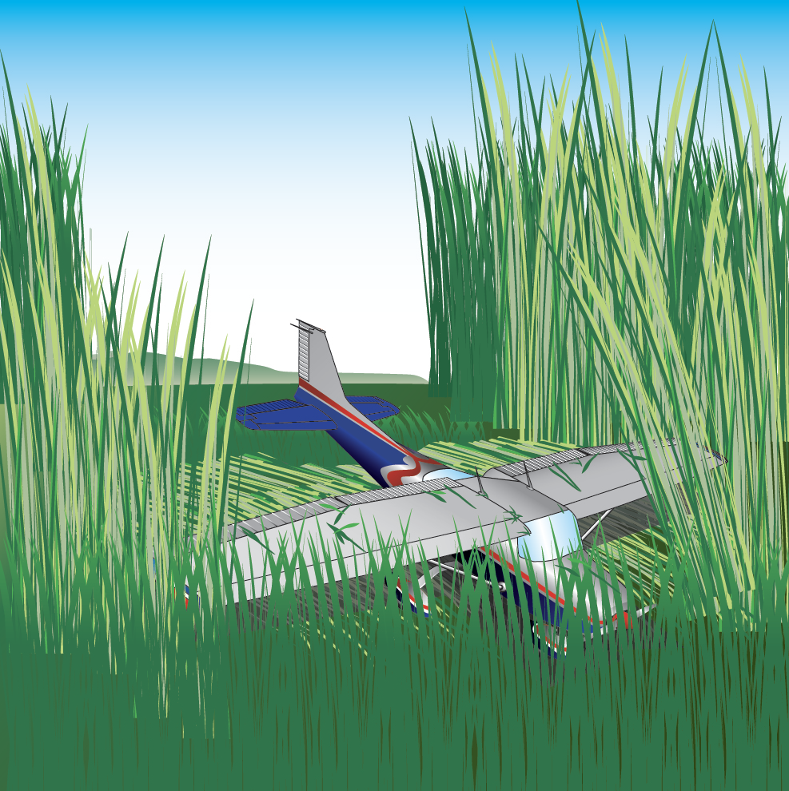

Figure 18-1. Using vegetation to absorb energy.
The overall severity of a deceleration process is governed by speed (groundspeed) and stopping distance. The most critical of these is speed; doubling the groundspeed means quadrupling the total destructive energy and vice versa. Even a small change in groundspeed at touchdown—be it because of wind or pilot technique—affects the outcome of a controlled crash. It is important that the actual touchdown during an emergency landing be made at the lowest possible controllable airspeed, using all available aerodynamic devices.
Most pilots instinctively—and correctly—look for the largest available flat and open field for an emergency landing. Actually, very little stopping distance is required if the speed can be dissipated uniformly; that is, if the deceleration forces can be spread evenly over the available distance. This concept is designed into the arresting gear of aircraft carriers that provides a nearly constant stopping force from the moment of hookup.
The typical light airplane is designed to provide protection in crash landings that expose the occupants to nine times the acceleration of gravity (9G) in a forward direction. Assuming a uniform 9G deceleration, at 50 mph the required stopping distance is about 9.4 feet. While at 100 mph, the stopping distance is about 37.6 feet—about four times as great. [Figure 18-2] Although these figures are based on an ideal deceleration process, it is interesting to note what can be accomplished in an effectively used short stopping distance. Understanding the need for a firm but uniform deceleration process in very poor terrain enables the pilot to select touchdown conditions that spread the breakup of dispensable structure over a short distance, thereby reducing the peak deceleration of the cabin area.
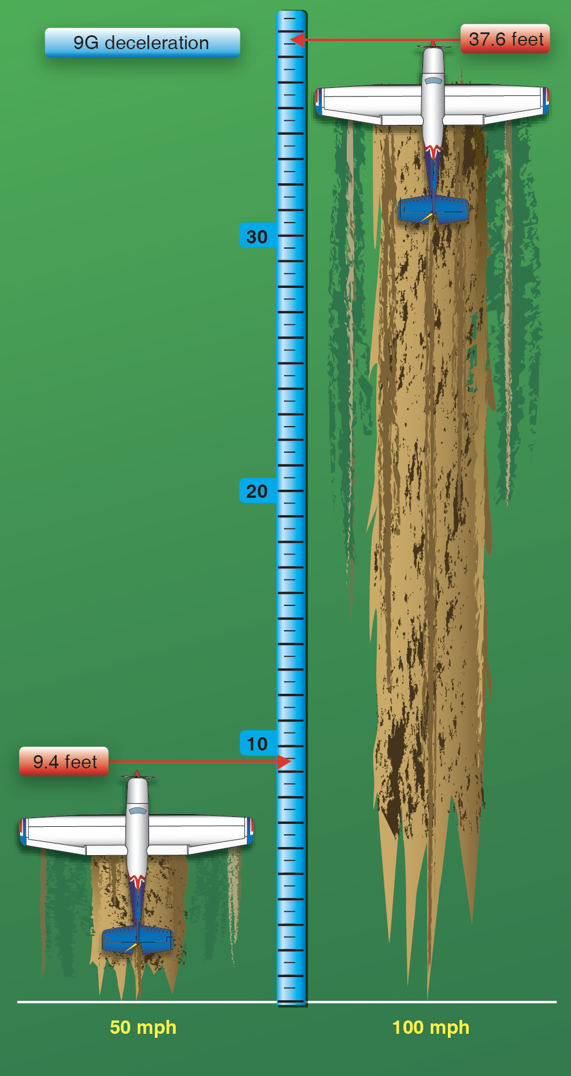

Figure 18-2. Stopping distance vs. groundspeed.
Attitude and Sink Rate Control
The most critical and often the most inexcusable error that can be made in the planning and execution of an emergency landing, even in ideal terrain, is the loss of initiative over the airplane’s attitude and sink rate at touchdown. When the touchdown is made on flat, open terrain, an excessive nose-low pitch attitude brings the risk of “sticking” the nose in the ground. Steep bank angles just before touchdown should also be avoided, as they increase the stalling speed and the likelihood of a wingtip strike.
Since the airplane’s vertical component of velocity is immediately reduced to zero upon ground contact, it should be kept well under control. A flat touchdown at a high sink rate (well in excess of 500 feet per minute (fpm)) on a hard surface can be injurious without destroying the cabin structure, especially during gear-up landings in low-wing airplanes. A rigid bottom construction of these airplanes may preclude adequate cushioning by structural deformation. Similar impact conditions may cause structural collapse of the overhead structure in high-wing airplanes. On soft terrain, an excessive sink rate may cause digging in of the lower nose structure and severe forward deceleration.
Terrain Selection
A pilot’s choice of emergency landing sites is governed by:
⦁ The route selected during preflight planning
⦁ The height above the ground when the emergency occurs
⦁ Excess airspeed (excess airspeed can be converted into distance and/or altitude)
The only time the pilot has a very limited choice is during the low and slow portion of the takeoff. However, even under these conditions, the ability to change the impact heading only a few degrees may ensure a survivable crash.
If beyond gliding distance of a suitable open area, the pilot should judge the available terrain for its energy absorbing capability. If the emergency starts at a considerable height above the ground, the pilot should be more concerned about first selecting the desired general area than a specific spot. Terrain appearances from altitude can be very misleading and considerable altitude may be lost before the best spot can be pinpointed. For this reason, the pilot should not hesitate to discard the original plan for one that is obviously better. However, as a general rule, the pilot should not change his or her mind more than once; a well-executed crash landing in poor terrain can be less hazardous than an uncontrolled touchdown on an established field.
Airplane Configuration
Since flaps improve maneuverability at slow speed, and lower the stalling speed, their use during final approach is recommended when time and circumstances permit. However, the associated increase in drag and decrease in gliding distance call for caution in the timing and the extent of their application; premature use of flap and dissipation of altitude may jeopardize an otherwise sound plan.
A hard and fast rule concerning the position of a retractable landing gear at touchdown cannot be given. In rugged terrain and trees, or during impacts at high sink rate, an extended gear would definitely have a protective effect on the cabin area. However, this advantage has to be weighed against the possible side effects of a collapsing gear, such as a ruptured fuel tank. As always, the manufacturer’s recommendations as outlined in the AFM/POH should be followed.
When a normal touchdown is assured, and ample stopping distance is available, a gear-up landing on level, but soft terrain or across a plowed field may result in less airplane damage than a gear-down landing. [Figure 18-3] Deactivation of the airplane’s electrical system before touchdown reduces the likelihood of a post-crash fire.
However, the battery master switch should not be turned off until the pilot no longer has any need for electrical power to operate vital airplane systems. Positive airplane control during the final part of the approach has priority over all other considerations, including airplane configuration and checklist tasks. The pilot should attempt to exploit the power available from an irregularly running engine; however, it is generally better to switch the engine and fuel off just before touchdown. This not only ensures the pilot’s initiative over the situation, but a cooled-down engine reduces the fire hazard considerably.
Approach
When the pilot has time to maneuver, the planning of the approach should be governed by the following three factors:
⦁ Wind direction and velocity
⦁ Dimensions and slope of the chosen field
⦁ Obstacles in the final approach path
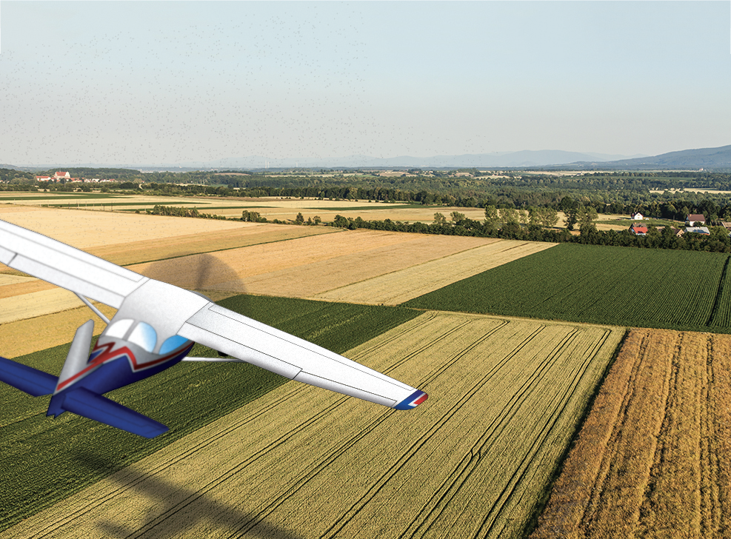
Figure 18-3. Intentional gear-up landing.
These three factors are seldom compatible. When compromises must be made, the pilot should aim for a wind/obstacle/terrain combination that permits a final approach with some margin for error in judgment or technique. A pilot who overestimates the gliding range may be tempted to stretch the glide across obstacles in the approach path. For this reason, it is sometimes better to plan the approach over an unobstructed area, regardless of wind direction. Experience shows that a collision with obstacles at the end of a ground roll or slide is much less hazardous than striking an obstacle at flying speed before the touchdown point is reached.
Terrain Types
Since an emergency landing on suitable terrain resembles a situation in which the pilot should be familiar through training, only the more unusual situations are discussed.
Confined Areas
The natural preference to set the airplane down on the ground should not lead to the selection of an open spot between trees or obstacles where the ground cannot be reached without making a steep descent.
Once the intended touchdown point is reached, and the remaining open and unobstructed space is very limited, it may be better to force the airplane down on the ground than to delay touchdown until it stalls (settles). An airplane decelerates faster after it is on the ground than while airborne. Thought may also be given to the desirability of ground-looping or retracting the landing gear in certain conditions.
A river or creek can be an inviting alternative in otherwise rugged terrain. The pilot should ensure that the water or creek bed can be reached without snagging the wings. The same concept applies to road landings with one additional reason for caution: manmade obstacles on either side of a road may not be visible until the final portion of the approach.
When planning the approach across a road, it should be remembered that most highways and even rural dirt roads are paralleled by power or telephone lines. Only a sharp lookout for the supporting structures or poles may provide timely warning.
Trees (Forest)
Although a tree landing is not an attractive prospect, the following general guidelines help to make the experience survivable.
- Use the normal landing configuration (full flaps, gear down).
- Keep the groundspeed low by heading into the wind.
- Make contact at minimum indicated airspeed, but not below stall speed, and “hang” the airplane in the tree branches in a nose-high landing attitude. Involving the underside of the fuselage and both wings in the initial tree contact provides a more even and positive cushioning effect, while preventing penetration of the windshield. [Figure 18-4]
- Avoid direct contact of the fuselage with heavy tree trunks.
- Low, closely spaced trees with wide, dense crowns (branches) close to the ground are much better than tall trees with thin tops; the latter allow too much free fall height (a free fall from 75 feet results in an impact speed of about 40 knots, or about 4,000 fpm).
- Ideally, initial tree contact should be symmetrical; that is, both wings should meet equal resistance in the tree branches. This distribution of the load helps to maintain proper airplane attitude. It may also preclude the loss of one wing, which invariably leads to a more rapid and less predictable descent to the ground.
- If heavy tree trunk contact is unavoidable once the airplane is on the ground, it is best to involve both wings simultaneously by directing the airplane between two properly spaced trees. Do not attempt this maneuver, however, while still airborne.

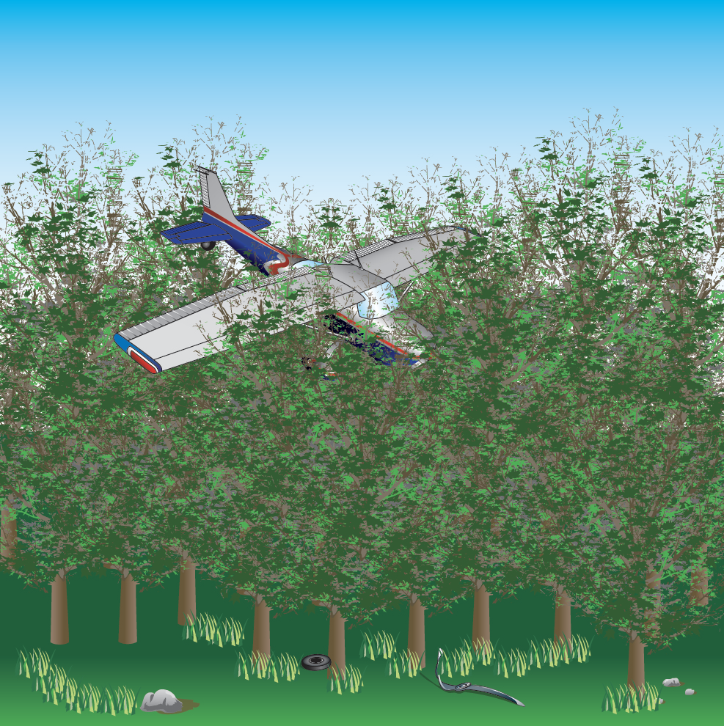

Figure 18-4. Tree landing.
Water (Ditching) and Snow
A well-executed water landing normally involves less deceleration violence than a poor tree landing or a touchdown on extremely rough terrain. Also, an airplane that is ditched at minimum speed and in a normal landing attitude does not immediately sink upon touchdown. Intact wings and fuel tanks (especially when empty) provide floatation for at least several minutes, even if the cabin may be just below the water line in a high-wing airplane.
Loss of depth perception may occur when landing on a wide expanse of smooth water with the risk of flying into the water or stalling in from excessive altitude. To avoid this hazard, the airplane should be “dragged in” when possible. Use no more than intermediate flaps on low-wing airplanes. The water resistance of fully extended flaps may result in asymmetrical flap failure and slowing of the airplane. Keep a retractable gear up unless the AFM/POH advises otherwise.
A landing in snow should be executed like a ditching, in the same configuration and with the same regard for loss of depth perception (white out) in reduced visibility and on wide-open terrain.

Engine Failure After Takeoff (Single-Engine)
Multiple variables and pilot actions factor into a successful emergency landing shortly after takeoff. When an engine failure occurs during the initial climb, the pilot should lower the nose of the airplane and establish the proper glide attitude. What happens next if the engine does not restart? Does the pilot select a field directly ahead (or slightly to the side of the takeoff path) or should the pilot turn back toward the point of departure? There is not much time to decide and a lot to consider. Any consideration of a return toward the departure runway should be based on pre-takeoff planning and briefing, as the time available following an engine failure after takeoff is insufficient for meaningful analysis once airborne.
Continuing straight ahead or making a slight turn gives the pilot time to establish a safe landing attitude, and the landing occurs under control and as slowly as possible (assuming a takeoff made into a headwind). This minimizes the risk of injury and usually represents the option with the lowest risk—i.e., the safest option. Turning back requires a more complex analysis and consideration of risk. At some urban airports, there may be numerous hazards in the departure path. In that case, the pilot may consider a turn back, but only if that option was planned and briefed prior to takeoff and certain the airplane can reach the field from its current position and the pilot has trained and practiced the turn-back maneuver.
Turning back to an airport after a low-altitude engine failure, also known as “the impossible turn,” presents many challenges, and a pilot who attempts to turn back without due consideration and training will need considerable luck to prevent disaster. If the airplane strikes the ground during the turn, cartwheeling could occur. If the pilot does not lower the nose sufficiently during the turn, an accelerated stall and fatal crash may occur. Even after executing a successful turn, a return to the airport often results in a downwind approach. The increased groundspeed could rush a pilot not properly trained for landing downwind. The increased groundspeed and associated increase in kinetic energy also raise the likelihood of serious injury if unable to make the field.
If considering a turn back to the runway following an engine failure on takeoff, the pilot must recognize that the outcome is governed by multiple interacting variables rather than a single altitude threshold. These variables include the airplane’s climb performance prior to the failure, pilot reaction time, the prompt establishment of a safe glide attitude, wind conditions, turn direction, bank angle, and the airplane’s ability to maintain adequate margin above stall angle of attack while maneuvering. Altitude is lost during the initial recognition and response, during the turning maneuver itself, and again while transitioning from the turn to a stabilized glide toward the runway. Failure to account for any of these factors can result in insufficient altitude to complete the maneuver safely. [Figure 18-5]

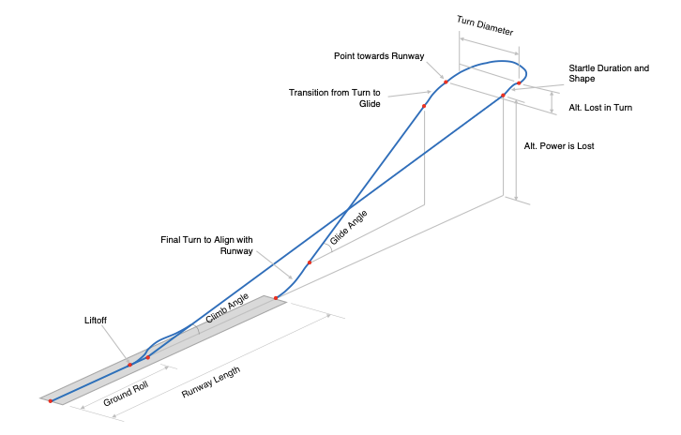
Figure 18-5. Factors effecting the ability to turn-back to the departure runway after power loss
Training for a turn back includes practicing turns in both directions at a safe altitude in the make and model flown after simulating an engine failure from a climb. Practice should result in consistent altitude loss and the ability to avoid an accelerated stall when executing a gliding steep turn. Pilots should be alert for and respond appropriately to any stall warning and reduce wing loading during the turn as necessary. There will be some observed variation in altitude loss during training. The pilot should anticipate that during an actual emergency, the expected altitude loss could end up at the high end of the range observed while practicing. Success in training involves the demonstrated ability to evaluate the effect of climb performance of the airplane, determine the better direction to turn back (usually into a crosswind), predict the altitude above ground after the turn, know the distance to the landing zone, and know if the glide performance of the airplane will allow the pilot to make the field. Some airplanes cannot usually make the return successfully, some can make the return under certain conditions, and some can usually return, but there are simply too many variables to make an uninformed, snap decision.
The pilot should not attempt a turn back unless pre-takeoff planning, training, and demonstrated airplane performance indicate that a successful return is achievable under the existing conditions, and unless the pilot can maintain adequate margin above stall angle of attack throughout the maneuver.
Emergency Descents
An emergency descent is a maneuver for descending as rapidly as possible to a lower altitude or to the ground for an emergency landing. [Figure 18-6] The need for this maneuver may result from an uncontrollable fire, a sudden loss of cabin pressurization, or any other situation demanding an immediate and rapid descent. The objective is to descend the airplane as soon and as rapidly as possible while not exceeding any structural limitations of the airplane. Simulated emergency descents should be made in a turn to check for other air traffic below and to look around for a possible emergency landing area. A radio call announcing descent intentions may be appropriate to alert other aircraft in the area. When initiating the descent, a bank of approximately 30 to 45° should be established to maintain positive load factors (G forces) on the airplane.
Emergency descent training should be performed as recommended by the manufacturer, including the configuration and airspeeds. Except when prohibited by the manufacturer, the power should be reduced to idle, and the propeller control (if equipped) should be placed in the low pitch (or high revolutions per minute (rpm)) position. This allows the propeller to act as an aerodynamic brake to help prevent an excessive airspeed buildup during the descent. The landing gear and flaps should be extended as recommended by the manufacturer. This provides maximum drag so that the descent can be made as rapidly as possible, without excessive airspeed. The pilot should not allow the airplane’s airspeed to pass the never-exceed speed (VNE), the maximum landing gear extended speed (VLE), or the maximum flap extended speed (VFE), as applicable. In the case of an engine fire, a high airspeed descent could blow out the fire. However, the weakening of the airplane structure is a major concern and descent at low airspeed would place less stress on the airplane. If the descent is conducted in turbulent conditions, the pilot also needs to comply with the design maneuvering speed (VA) limitations. The descent should be made at the maximum allowable airspeed consistent with the procedure used. This provides increased drag and a high rate of descent. The recovery from an emergency descent should be initiated at a high enough altitude to ensure a safe recovery back to level flight or a precautionary landing.
REST OF CHAPTER REMAINS UNCHANGED

